**Stamford Online Journal System**

*A Project Submitted in Partial Fulfillment of the Requirements for the*

*Degree of*

Bachelor of Science in Computer Science and Engineering

*by*

**Deep Bhowmik**

CSE 05506822

&

**Joyonto Kumar Roy**

CSE 05406795

Supervised by: TarikuzzamanEmon

Assistant Professors and Coordinator Senior Lecturer

|  |
| --- |
| C:\Users\Adnan\Desktop\1.jpg |

Department of Computer Science and Engineering

STAMFORD UNIVERSITY BANGLADESH

March 2019

**Abstract**

The goal of this journal system is to increase the visibility to the participating journals, use and impact of the university's research publications by offering them to use through the university's own online journal system. The journal system consists of full text materials produced in the Stamford University, covering the full range of academic journals of the University. An efficient and dynamic online journal system which university students can read and download a journal and if they want they can upload their own journal in this website. Abstracts of journal papers are sometimes students or user written, often lack important information, and occasionally convey a biased picture. The primary target of this journal paper is the main types of university department categories information. If somebody need to post a journal before they need to register and then go.

**Declaration**

We, hereby, declare that the work presented in this Project is the outcome of the investigation performed by us under the supervision of Tarikuzzaman Emon, Assistant Professors and Coordinator, Department of Computer Science & Engineering, Stamford University Bangladesh.

Signature and Date:

**……………………………...**

**Student Name:**

Date:

**……………………………...**

**Student Name:**

Date:

Dedicated Our beloved parents and our honorable supervisor sir Tarikuzzaman Emon.

**Acknowledgements**

At first we would like to thank the almighty ALLAH for giving me ability, chance and such cooperating supervisor. With Her mercy, today we are completing our thesis work successfully.

We would like to take the opportunity to express my gratitude to Tarikuzzaman Emon sir our respected supervisor. Although she was always loaded with several other activities, he gave more than enough time in this work. He not only gave me time but also proper guidance and valuable advice whenever we faced with some difficulties. Her comments and guidance helped me in preparing our project report.

We would like to thank all my respected teachers, who inspired me in every step. We also thankful to my friends who helped me in a number of ways by providing various resources and moral support.

Last but not least we are grateful to our family; who are, always with us in our every step of life.

Table of Contents

List of Figures 1

List of Tables 2

1: Introduction 4

1.1 Problem Defination 4

1.2 Motivation 4

1.3 Chapter Summary 4

2: Background Study 6

2.1Existing related system 6

2.2Literature Review 6

2.2.1 PHP 6

2.2.2 HTML 7

2.2.3 CSS 7

2.2.4 Jquery 8

2.2.5 MySQL 9

2.3ChapterSummary 9

3: System Requirement 11

3.1Software& Hardware11

3.1.1Software Requirements 11

3.1.2Hardware Requirements 11

3.2 Software setup process 12

3.2.1XAMPP server setup  12

3.3 PHP(hypertext Preprocessor 21

3.4 Why use A PHP Framework 22

3.4.1 Below is same advantage PHP Framework 22

3.4.2 Laravel Framework 23

3.3ChapterSummary 23

4:Project Details 32

4.1DatabaseDetails 33

4.2SystemDesign 37

4.2.1 Timeline Chart………………………………………………………...……….37

4.2.2 System Flowchart……………………………………………………...……….38

4.2.3E-R Diagram…………………………………...……………………...……….39

4.2.4Use Case Diagram…………………………………………………...…..…….40

4.2.5Activity Diagram……………………………………………………...……….42

4.2.6 Sequence Diagram……………………………………..……………...……….45

4.2.7Collaboration Diagram………………………………………………...……….46

4.3Input Project Design 49

4.4ChapterSummary 56

5: Conclusion& Future Work 57

5.1Futurewrok 58

References 59

# List of Figures

Figure 3.1: Xampp Server Setup Process………………………………………….……….23

Figure 3.2: Xampp Control Panel………………………………………………………….27

Figure 4.0.2: Timeline Chart…………………………………………………………………37

Figure 4.0.3: System FlowChart…………………………………………………………......38

Figure 4.0.4:E-R Diagram……………………………………………………………………39

Figure 4.0.5:Use Case Diagram Admin…………………………………………………......40

Figure 4.0.5:Use Case Diagram Home Owner…………………………………………........41

Figure 4.0.6:Use Case Diagram Home Seeker…………………………………………........41

Figure 4.0.6:Activity Diagram Admin……………………………………………………….42

Figure 4.0.8:Activity Diagram Supplier……………………………………………………..43

Figure 4.0.9:Activity Diagram Home Seeker………………………………………………..44

Figure 4.0.7: Sequence Diagram Admin……………………………………………………..45

Figure 4.0.8: Sequence Diagram Supplier……………………………………………………45

Figure 4.0.12: Sequence Diagram Buyer…………………………………………………….46

Figure 4.0.9:Collaboration Diagram Admin…………………………………………………47

Figure 4.0.14:Collaboration Diagram Home Owner…………………………………………48

Figure 4.0.15:Collaboration Diagram Home Seeker…………………………………………48

Figure 4.0.10: User Interface Home………………………………………………….………49

Figure 4.0.11: User Interface Properties……………………………………………………..49

Figure 4.0.12: User Interface Contact………………………………………………………..50

Figure 4.0.13:Contact Form………………………………………………………………….50

Figure 4.0.14:Register New Account………………………………………………………...51

Figure 4.0.15:User Interface Login…………………………………………………………..52

Figure 4.0.16: User Interface Submit Property………………………………………………52

Figure 4.0.17: Admin Panel Login…………………………………………………………...54

Figure 4.0.18: Admin Panel Dashboard……………………………………………………...54

Figure 4.0.19: Admin Panel Property Table…………………………………………………55

Figure 4.0.20: Admin Panel Category Table…………………………………...……………55

Figure 4.0.21: Admin Panel User Table……………………………………………………..56

# List of Tables

Table 4.0.1: Users Table…………………………………………………………………....33

Table 4.0.2: Contact_info Table…………………………………………………………….34

Table 4.0.3:Property Table………………………………………………………………….35

Table 4.0.4:Category Table……………………………………………………………...…36

Table 4.0.5: Booking Table…………………………………………………………………36

# 

# Chapter 1

# Introduction

# 1 Introduction

We live in modern World. The most surprising contribution of this modern era is the internet. Since the Internet is invented, the world is moving fast. Modernity is going on in different parts of the world. As the Internet is moving the world, so has the human life much easier. The Internet is not backward in education. The role of the Internet in modern education is immense. Now almost all students are dependent on this internet, because all the books, journal and guides are available in this internet .So buying books or journal has decreased. It is a matter of thinking that we create online journal website. The website was originally designed for students. Many times, there is no place for the students to post journal of the university's website. There are many students who write a lot of good journals, mainly for them, this website. This website allows them to upload their own research and read the journal.

## Problem Definitions

A problem statement is a clear description of the issue(s), it includes a vision, issue statement, and method used to solve the problem. A problem statement expresses the words that will be used to keep the effort focused and it should represent a solvable problem. So here discuss problem why we are made this website. In our university there is no any website where student can read upload download journal. So that’s why we made a journal website for our university where all student can read upload and download there own journal.

* 1. ***Motivation***

Inspiration journals can hold your thoughts, ideas, inspirations, and dreams. Many people use inspiration journals as a way to stay motivated and to encourage themselves during difficult times. Deciding how to decorate your inspiration journal, find inspiration, what to write inside, and how often you’ll use it are all decisions that are unique to you! Use your journal frequently and use it as a way to motivate you to accomplish your goals and reflect on your life.

## Chapter Summary

In this chapter illustrates an introductory section of the system. Here we tried to introduce the users to our system. We tried to share the motivations and the objectives of the sytem with the users. In the upcoming chapters I will discuss about Literature Review of the Project, Project Outline, Requirement Analysis, Planning The Development Process, Project Requirement and Features and Workflow.

# Chapter 2

# Background Study

# 2 Background Study

I am a student of Stamford University There are many universities inside the dhaka. Our campus is the most beautiful inside of Dhaka. All universities have their own websites, so our university has websites. But it is sad to say that there is no place for students to post a journal to our website. The use of the internet in education is moving fast. Students are more than studying online from the book. Students want post their writing online through their research and for this reason, there need a special place. Which is not in our university website. There are many students who want to upload their own research paper online but they can not. With this thought, we decided to create a journal website for our university. Where student can upload, read and download any journal.

* 1. ***Literature Review***

2.2.1 PHP: PHP is a general-purpose scripting language that is especially suited to server-side web development, in which case PHP generally runs on a web server. Any PHP code in a requested file is executed by the PHP runtime, usually to create dynamic web page content or dynamic images used on websites or elsewhere. But There is a problem in core php . if you want to develop a sample login registration form using core php, you need to write a huge code, but you can easily handle login registration form used a single command using php framework.

**The major points of HTML are given below:**

* PHP stands for Hypertext Preprocessor.
* PHP is an interpreted language, i.e. there is no need for compilation.
* PHP is a server side scripting language.
* PHP is faster than other scripting language e.g. asp and jsp.

PHP example.

<!DOCTYPE**>**

**<html>**

**<body>**

**<?php**

echo "**<h2>**Hello by PHP**</h2>**";

**?>**

**</body>**

**</html>**

***2.2.2***HTML: HTML stands for Hyper Text Markup Language, which is the most widely used language on Web to develop web pages. HTML was created by Berners-Lee in late 1991 but "HTML 2.0" was the first standard HTML specification which was published in 1995. HTML 4.01 was a major version of HTML and it was published in late 1999. Though HTML 4.01 version is widely used but currently we are having HTML-5 version which is an extension to HTML 4.01, and this version was published in 2012.

The major points of HTML are given below:

* HTML stands for Hyper Text Markup Language.
* HTML is used to create web pages.
* HTML is widely used language on the web.
* We can create static website by HTML only.

HTML Example

<!DOCTYPE**>**

**<html>**

**<body>**

**<h1>**Write Your First Heading**</h1>**

**<p>**Write Your First Paragraph.**</p>**

**</body>**

**</html>**

2.2.3 CSS: CSS is used to control the style of a web document in a simple and easy way.The major points of CSS are given below:

* CSS stands for Cascading Style Sheet.
* CSS is used to design HTML tags.
* CSS is a widely used language on the web.
* HTML, CSS and JavaScript are used for web designing. It helps the web designers to apply style on HTML tags.

Example

<!DOCTYPE**>**

**<html>**

**<head>**

**<style>**

h1{

color:white;

background-color:red;

padding:5px;

}

p{

color:blue;

}

**</style>**

**</head>**

**<body>**

**<h1>**Write Your First CSS Example**</h1>**

**<p>**This is Paragraph.**</p>**

**</body>**

**</html>**

2.2.4 jQuery: jQuery is a fast and concise JavaScript library created by John Resig in 2006. jQuery simplifies HTML document traversing, event handling, animating, and Ajax interactions for Rapid Web Development.

* jQuery is a small and lightweight JavaScript library.
* jQuery is cross-platform.
* jQuery means "write less do more".
* jQuery simplifies AJAX call and DOM manipulation.

<!DOCTYPE html>

<html>

<head>

 <title>First jQuery Example</title>

<script type="text/javascript" src="http://ajax.googleapis.com/ajax/libs/jquery/2.1.3/jquery.min.js">

 </script>

 <script type="text/javascript" language="javascript">

 $(document).ready(function() {

 $("p").css("background-color", "pink");

 });

 </script>

 </head>

<body>

<p>This is first paragraph.</p>

<p>This is second paragraph.</p>

<p>This is third paragraph.</p>

</body>

</html>

2.2.5 MySQL: MySQL is the most popular Open Source Relational SQL Database Management System. MySQL is one of the best RDBMS being used for developing various web-based software applications. MySQL is developed, marketed and supported by MySQL AB, which is a Swedish company.

## Chapter Summary

In this chapter, we discuss the Code of the whole project what we have been use in our project. We use HTML,CSS,Bootstrap, PHP, Jquery, MySQL, Laravel.

# 

# Chapter 3

# System Requirement

# 3 System Requirement

This chapter aims to document the systems requirements and software setup process. There are two types of requirements Software Requirements and Hardware Requirements.

* 1. ***Software & Hardware***

The most common set of requirements defined by any [operating system](https://en.wikipedia.org/wiki/Operating_system) or [software application](https://en.wikipedia.org/wiki/Software_application) is the physical computer resources, also known as [hardware](https://en.wikipedia.org/wiki/Computer_hardware), A hardware requirements list is often accompanied by a [hardware compatibility list](https://en.wikipedia.org/wiki/Hardware_compatibility_list) (HCL), especially in case of operating systems. An HCL lists tested, compatible, and sometimes incompatible hardware devices for a particular operating system or application. The following sub-sections discuss the various aspects of hardware requirements.

[Software requirements](https://en.wikipedia.org/wiki/Software_requirements) deal with defining software resource requirements and prerequisites that need to be installed on a computer to provide optimal functioning of an application. These requirements or prerequisites are generally not included in the software installation package and need to be installed separately before the software is installed.

* + 1. **Software Requirements:**

1. XAMPP :Web Application Server

2. Sublime test 3 : Integrated Tools

3. MySQL : Database

4. OS: 64-bit Windows 10

5. Laravel 5.5 php framework

As a scripting language we have used PHP in backend and for the front end coding we have used HTML/CSS (bootstrap)

* + 1. **Hardware Requirements:**

1. Pentium 4 or AMD or Celeron Processor or above

2. RAM 4GB

* 1. ***Software setup process***

**Installation** (or **setup**) of a [computer program](https://en.wikipedia.org/wiki/Computer_program) (including [device drivers](https://en.wikipedia.org/wiki/Device_driver) and [plugins](https://en.wikipedia.org/wiki/Plug-in_(computing))), is the act of making the program ready for [execution](https://en.wikipedia.org/wiki/Execution_(computing)). Because the process varies for each program and each computer, programs (including [operating systems](https://en.wikipedia.org/wiki/Operating_system)) often come with an *installer*, a specialized program responsible for doing whatever is needed for their installation. Installation may be part of a larger [software deployment](https://en.wikipedia.org/wiki/Software_deployment) process.

* + 1. **XAMPP server setup:**

1. **Open the XAMPP website.** Go to  <https://www.apachefriends.org/index.html> in computer's web browser.

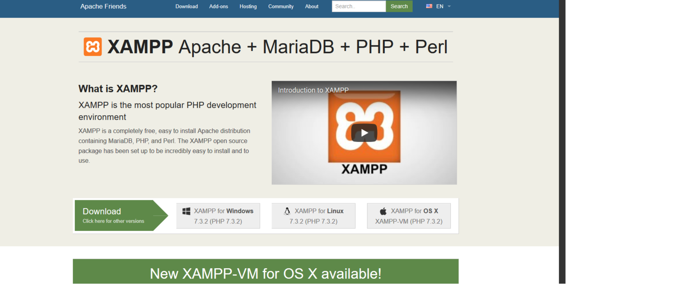

Figure 3.1: Xampp Server Download

1. **Click XAMPP for Windows.** It's a grey button near the bottom of the page.

Depending on your browser, you may first have to select a save location or verify the download.

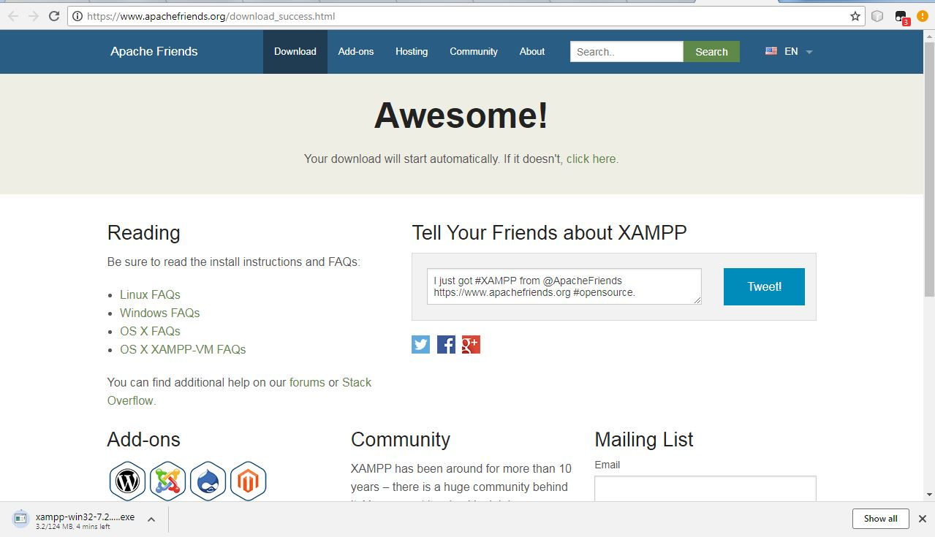

Figure 3.2: Xampp Server Downloading

1. **Double-click the downloaded file.** This file should be named something like **xampp-win32-7.2.4-0-VC15-installer**, and you'll find it in the default downloads location (e.g., the "Downloads" folder or the desktop).

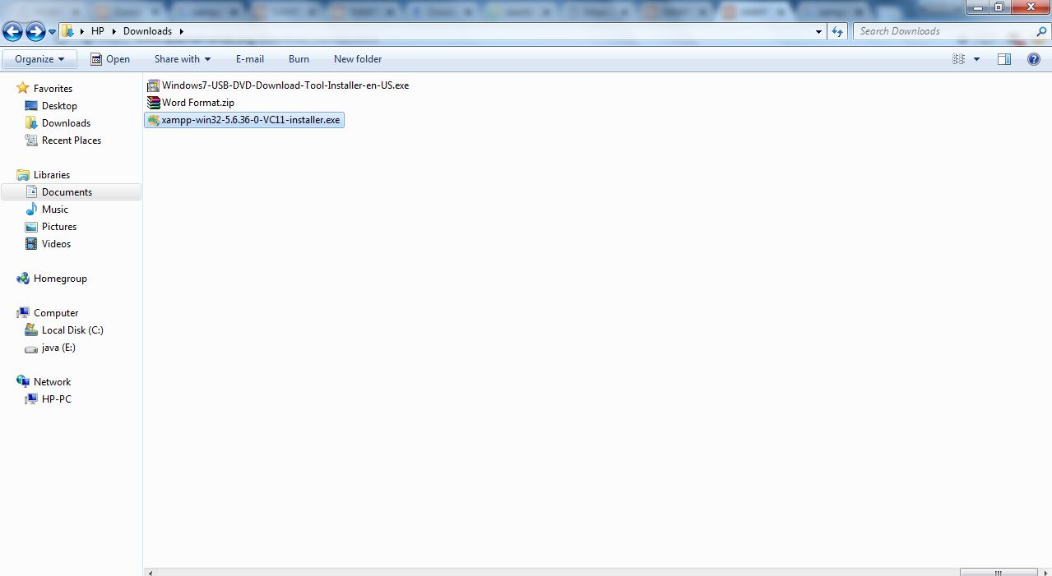

Figure 3.3: Xampp Server Downloading File

**4. Click Yes when prompted**This will open the XAMPP setup window. You may have to click **OK** on a warning if you have User Account Control (UAC)activated on your computer.

**5. Click Next.** It's at the bottom of the setup window.

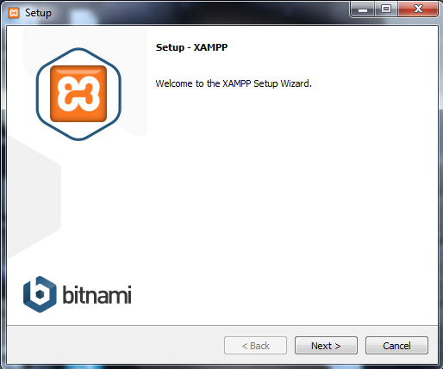

Figure 3.4:Xampp Server Setup Process

**6. Select aspects of XAMPP to install.** Review the list of XAMPP attributes on the left side of the window; if you see an attribute that you don't want to install as part of XAMPP, uncheck its box.

* By default, all attributes are included in your XAMPP installation.

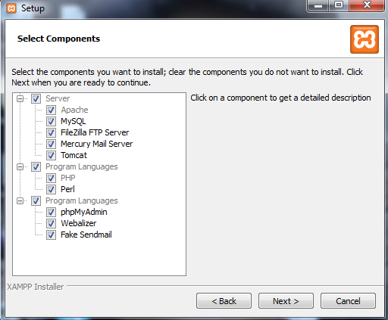

Figure 3.5:Xampp Server Setup Process

**7. Select an installation location.** Click the folder-shaped icon to the right of the current installation destination, then click a folder on your computer.

If you have the UAC activated on your computer, avoid installing XAMPP in your hard drive's folder (e.g., **OS (C:)**).

You can select a folder (e.g., **Desktop**) and then click **Make New Folder** to create a new folder and select it as the installation destination.

1. **Begin installing XAMPP.** Click **Next** at the bottom of the window to do so. XAMPP will begin installing its files into the folder that you selected.
2. **Click Finish when prompted.** It's at the bottom of the XAMPP window. Doing so will close the window and open the XAMPP Control Panel, which is where you'll access your servers.

**Click Next.** It's at the bottom of the window.

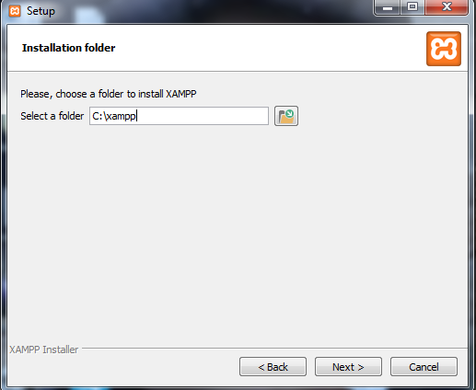

Figure 3.6:Xampp Server Setup Process

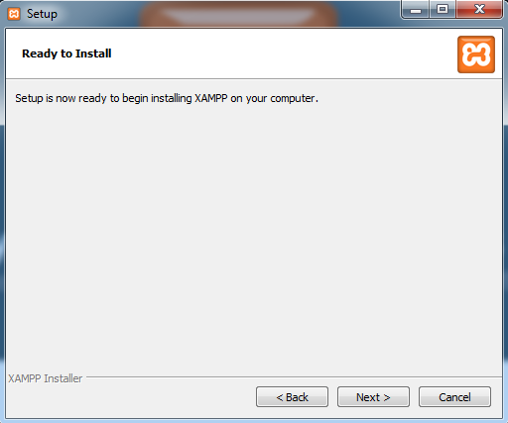

Figure 3.7:Xampp Server Setup Process

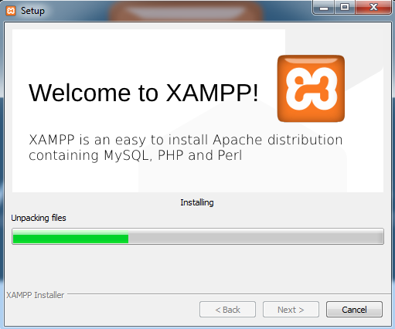

Figure 3.8: Xampp Server Setup Process

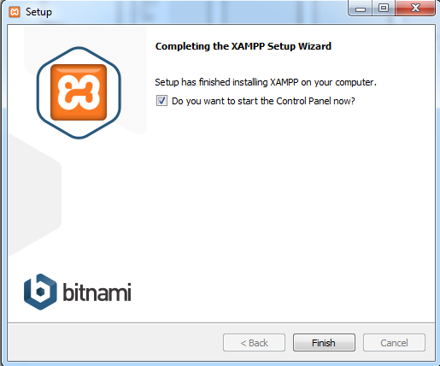

Figure 3.8: Xampp Server Setup Process

**8. Select a language.** Check the box next to the American flag for

English, or check the box next to the German flag for German.

**9. Click Save.** Doing so opens the main Control Panel page.

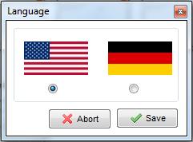

Figure 3.9: Xampp Server Setup Process(select a language)

10.Start XAMPP from its installation point. If you need to open the XAMPP Control Panel in the future, you can do so by opening the folder in which you installed XAMPP, right-clicking the orange-and-white xampp-control icon, clicking Run as administrator, and clicking Yes when prompted.

* When you do this, you'll see red X marks to the left of each server type (e.g., "Apache"). Clicking one of these will prompt you to click Yes if you want to install the server type's software on your computer.
* Counter intuitively, double-clicking the xampp_start icon doesn't start XAMPP.

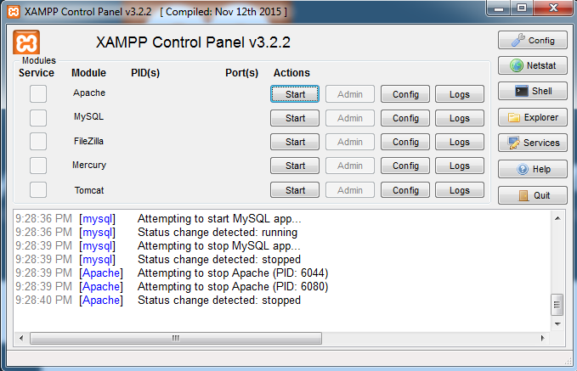Figure 3.10: Xampp Control Panel

**3.3 PHP (Hypertext Preprocessor)**

PHP is a server-side scripting language designed for web development but also used as a general-purpose programming language. Originally created by Rasmus Lerdorf in 1994,the PHP reference implementation is now produced by The PHP Group. PHP originally stood for *Personal Home Page*, but it now stands for the recursive  backronym *PHP: Hypertext Preprocessor*.

PHP code may be embedded into HTML code, or it can be used in combination with various web template systems, web content management systems and web frameworks. PHP code is usually processed by a PHP interpreter implemented as a module in the web server or as a Common Gateway Interface (CGI) executable. The web server combines the results of the interpreted and executed PHP code, which may be any type of data, including images, with the generated web page. PHP code may also be executed with a command-line interface (CLI) and can be used to implement standalone graphical applications.

The standard PHP interpreter, powered by the Zend Engine, is free software released under the PHP License. PHP has been widely ported and can be deployed on most web servers on almost every operating system and platform, free of charge.

The PHP language evolved without a written formal specification or standard until 2014, leaving the canonical PHP interpreter as  ade facto standard. Since 2014 work has gone on to create a formal PHP specification.

During the 2010s there have been increased efforts towards standardisation and code sharing in PHP applications by projects such as PHP-FIG in the form of PSR-initiatives as well as Composer dependency manager and the Packagist repository.

**3.4 Why Use A PHP Framework**

But first, let’s take a look at the top reasons why many developers like to use PHP frameworks and how these frameworks can level up your development process. Here’s what PHP frameworks do:

* Make speed development possible
* Provide well-organized, reusable and maintainable code
* Let you grow over time as web apps running on frameworks are scalable
* Spare you from the worries about low-level security of a site
* Follow the MVC (Model-View-Controller) pattern that ensures the separation of presentation and logic
* Promote modern web development practices such as object-oriented programming tools(3)

**3.4.1 Below is Some Advantages To Use PHP Framework:**

* Organize file and code structure
* Pre Build Libraries & Tools that can help you with
  + Database Abstraction
  + From Validation
  + Input/Output Filtering
  + Session & Cookie handling
* Faster Application Development using Less Code (Rapid application development)
* Model view control (MVC) Architecture
* Community support
* Suitable for teamwork
* Pretested Framework with
  + Any value passed to database object gets filtered against SQL injection attacks
  + central authentication service architecture
  + All HTML generating functions, such as form helpers and URL helpers filter the output automatically
  + Cross Site Request Forgery (CSRF) Protection
  + session management security integration
  + client-side cross-site scripting protection (xss)
  + Encrypting cookies automatically is only a matter of changing a config option and lot more.

**3.4.2 Laravel Framework**

Although Laravel is a relatively new PHP framework (it was released in 2011), according to Site point’s recent online survey it is the most popular framework among developers. Laravel has a huge ecosystem with an instant hosting and deployment platform, and its official website offers many screencast tutorials called Laracasts.

Laravel has many features that make rapid application development possible. Laravel has its own light-weight templating engine called “Blade”, elegant syntax that facilitates tasks you frequently need to do, such as authentication, sessions, queueing, caching and RESTful routing. Laravel also includes a local development environment called Homestead that is a packaged Vagrant box.

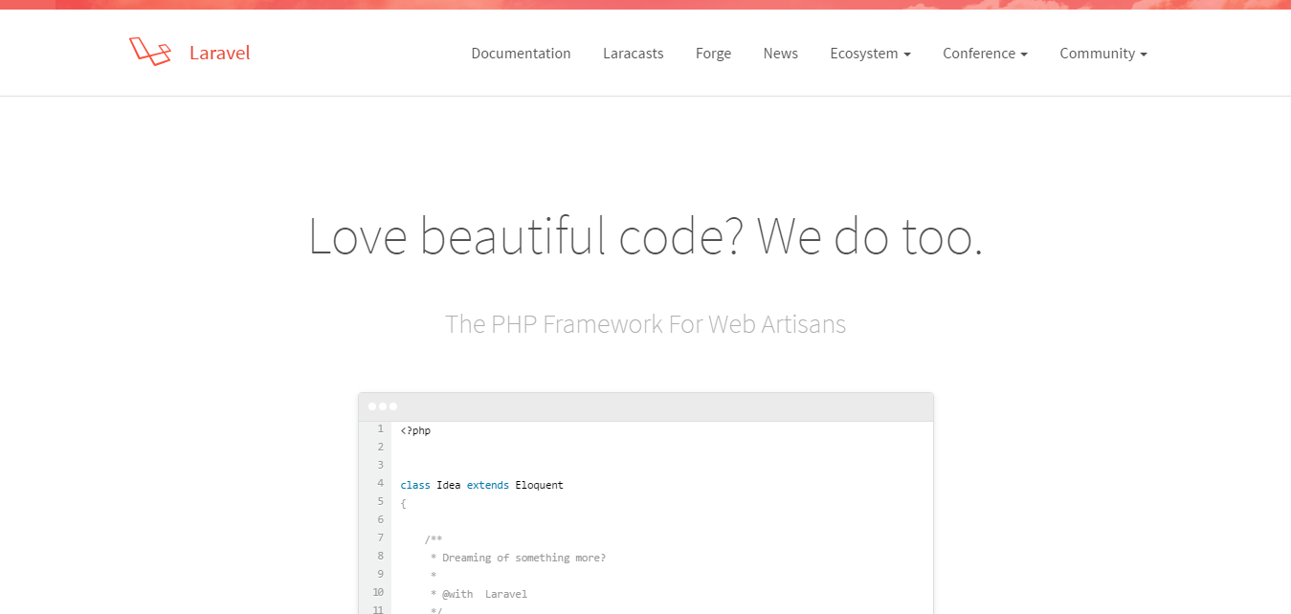

Figure 3.11 Laravel Framework

**3.4.3 Why Use Laravel Framework**

* Over the last year, I took part in three large projects. My task was to move away from the old architecture based on PHP and server-side HTML generation, and transition to REST API.
* With the old approach, back-end developers were expected to know much more about the UI and visual aspects of the application. Because of this, they had to pay attention to different segments of the application, instead of focusing on their primary objective. Having the back-end API strictly separated from the UI allowed our developers to focus on the quality of their code.
* Also, testing API services is much easier as REST API can be verified by automated unit testing.
* I’ve had some experience in writing my own framework, as well as working with Yii, CakePHP, CodeIgniter and few other open source frameworks. Each time, I’ve experienced a lack of functionality or awkward approach to some problems.
* I used Laravel for four months before deciding to choose it as the platform for our next project. The project itself was a great success and this article is a product of this experience.



Figure 3.12 Laravel Framework

3.5 Chapter Summary:

In this chapter, we discuss about the system requirements, what kind of software and hardware are require in this project that have been discuss. There have also the software setup process.

# Chapter 4

# Project Details

# Project Details

Functional Requirements are the fundamental basic requirements of a system. To capture functional requirements we have used the most widely used Database details and the system use case diagram of the system.

**4.1 Database Details**

Database is the base of system in project, Here we add all the database of the project. we use MySQL for the database. Because it is user friendly.

Table-Name: Users

Primary-key: user_id

Description:This table Users is used to registration and login into all user to access the Website.

Table 4.: Users Table

|  |  |  |
| --- | --- | --- |
| Name | Type | Comments |
| user_id | Int(11) |  |
| Username | Varchar(50) |  |
| Address | Varchar(50) |  |
| Email | Varchar(50) |  |
| City | Varchar(50) |  |
| Division | Varchar(50) |  |
| Zipcode | Varchar(50) |  |
| contactNo | Varchar(50) |  |
| userRole | Tinyint(1) | Admin=1,home_seeker=2,  home_owner=3. |
| Password | Varchar(50) |  |
| Country | Varchar(50) |  |

Table-Name: Contact_info

Primary-key: info_id

Description: This table Contact_info ,here user can send there feedback to the admin from the website.

Table 4.: Contact_info Table

|  |  |  |
| --- | --- | --- |
| Name | Type | Null |
| info_id | Int(10) | No |
| Username | Varchar(50) | No |
| Email | Varchar(50) | No |
| Subject | Varchar(50) | No |
| Message | Varchar(50) | No |

Table-Name: property

Primary-key: property_id

Description: This table property, here have all the property details,user can show that details and home owner add the their property here and need to admin approval for post the property to the property table.

Table 4.:Property Table

|  |  |  |
| --- | --- | --- |
| Name | Type | Null |
| property_id | Int(11) | No |
| property_location | Varchar(50) | No |
| Num_of_room | Int(50) | No |
| Num_of_bath | Int(50) | No |
| Property_size | Varchar(50) | No |
| Property_image | Varchar(500) | No |
| Property_description | Varchar(255) | Yes |
| Property_price | Double(255) | No |
| Category_id | Int(11) | No |
| User_id | Int(11)` | No |
| Status | Tinyint(1) | No |
| Date_added | Timestamp | No |
| Country | Varchar(50) | No |
| City | Varchar(50) | No |
| Phone_number | Varchar(50) | No |

Table-Name: tbl_category

Primary-key: category_id

Description: This table tbl_category, have all the category of the property, only admin can add/update/delete the information of this table.

Table 4.:Category Table

|  |  |  |
| --- | --- | --- |
| Name | Type | Null |
| Category_id | Int(11) | No |
| Category_name | Varchar(100) | No |

Table-Name: Order Details

Primary-key: order_id

Description: This table order details, have the information of those home-seeker who order or booked the selected home.

Table 4.: Booking Table

|  |  |  |
| --- | --- | --- |
| Name | Type | Null |
| Order_id | Int(11) | No |
| homeSeeker_id | Int(11) | No |
| Property_id | Int(11) | No |
| Date_of_booked | Timestamp | No |

**4.2 Use Case Diagram**

A Use case is a summary of scenarios for a single task or goal. An actor is who or what initiates the events involved in that task. Actors are simple roles that people or objects play. The picture below showing the Use case diagram for admin

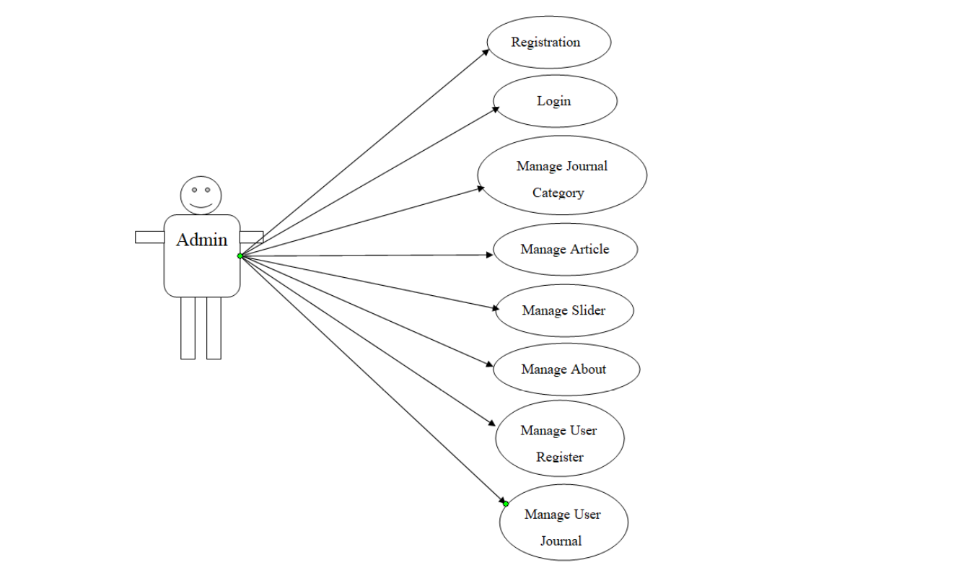

Figure 4.1:Use Case Diagram For Admin

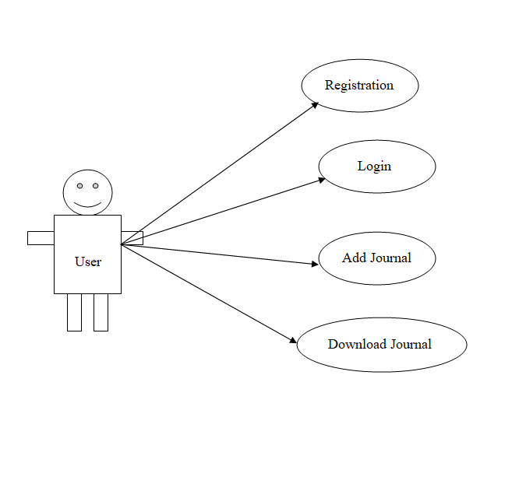 Figure 4.2:Use Case Diagram For User

This is the use case diagram for admin and user. Admin can manage all things and user can add their journal read and if they want they can download any journal.

* 1. **Input Project Design**

**Page-Name:** User Interface Home

**Description:** In the home page, It is the user interface of the system here user can search any departmental journal of their own choice.

 

Figure 4.3: User Interface Home

**Page-Name:** User Interface Contact

**Description:** In this page user can contact with the admin with the phone-number or the email have been provided.

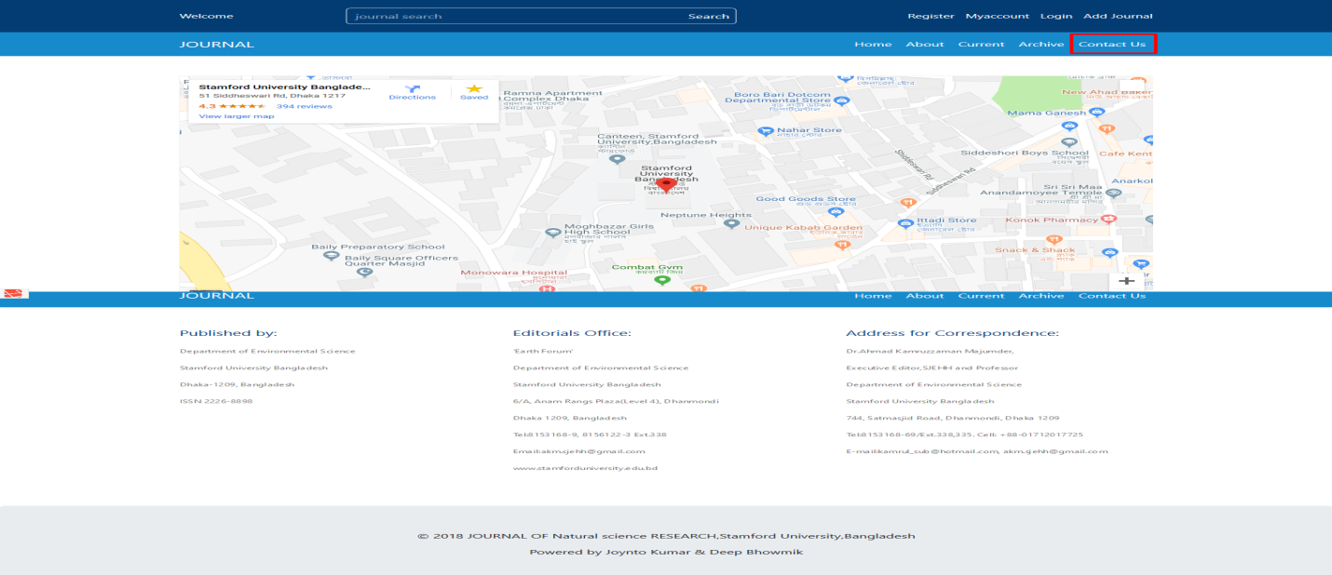

Figure 4.4:User Interface Contact

**Page-Name:** User Interface About

**Description:** In this page, user can know details about this website.

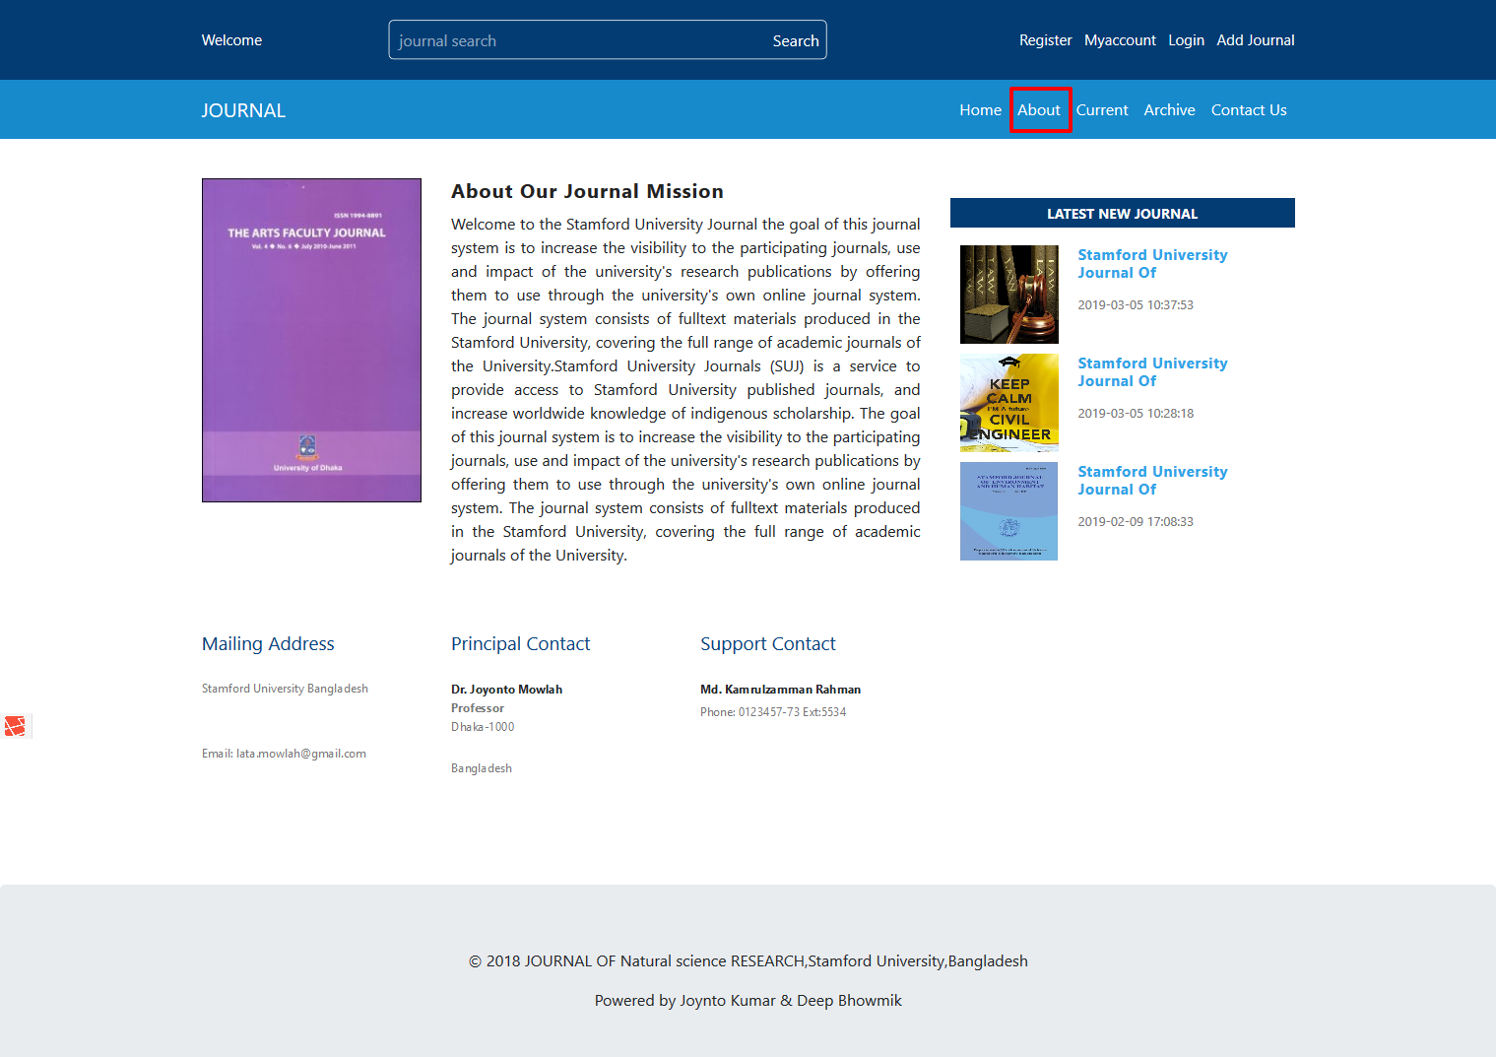

Figure 4.4:User Interface About

**Page-Name:** Register A New Account

**Description:** When A user want to upload a journal, they must have to register first. Register with their name, email, contact, password, address, city, country and have to confirm password and it must be match.

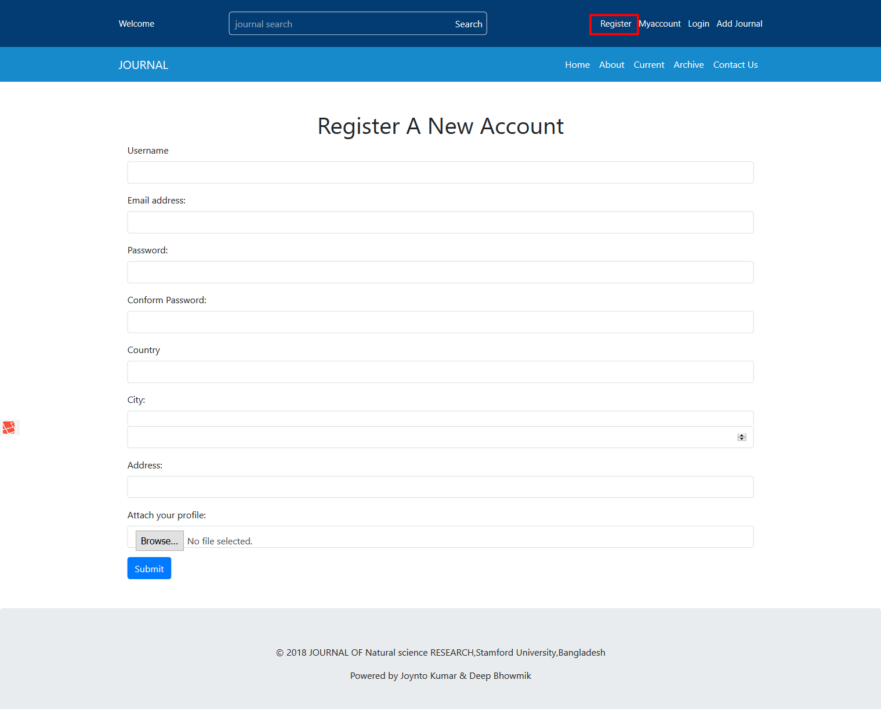

Figure 4.5:Register New Account

**Page-Name:** User Interface Login

**Description:** In this section a home seeker login with their email and password. Then he submit his property and also edit or delete his property.

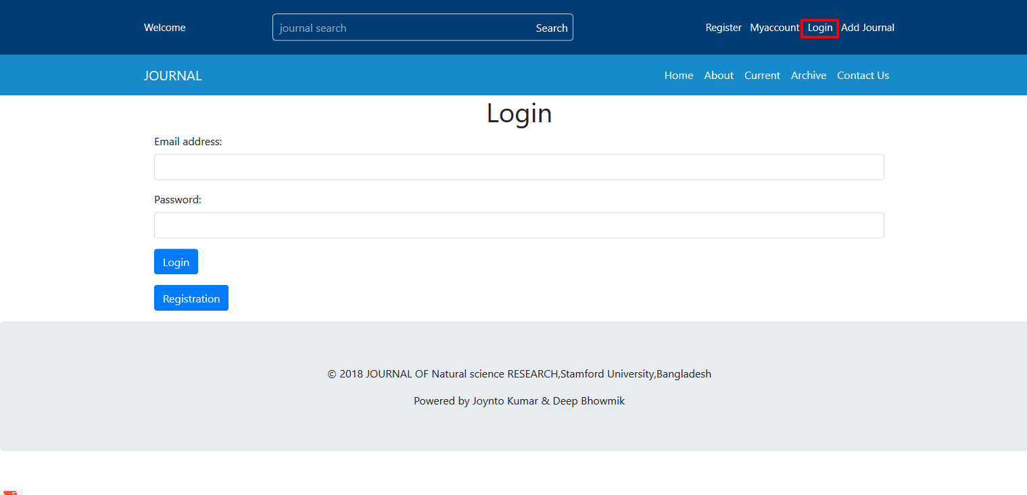 Figure 4.6:User Interface Login

**Page-Name:** User Interface Current

**Description:** In this page, user can see latest journal which upload any user and admin.



Figure 4.6:User Interface Current

**Page-Name:** User Interface Archive

**Description:** In this page, user can see old journal. 1st fifteen uploaded by admin and 1st fifteen uploaded by user journal.

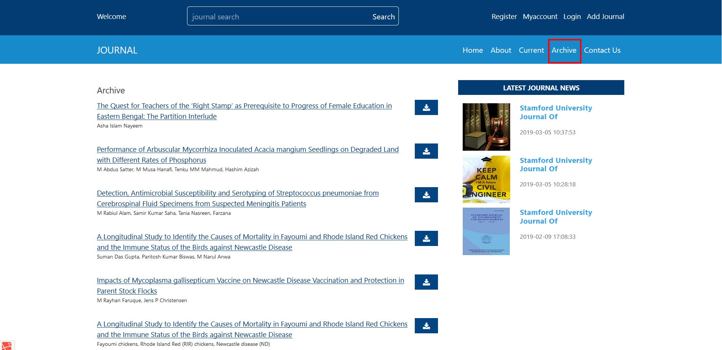

Figure 4.6:User Interface Archive